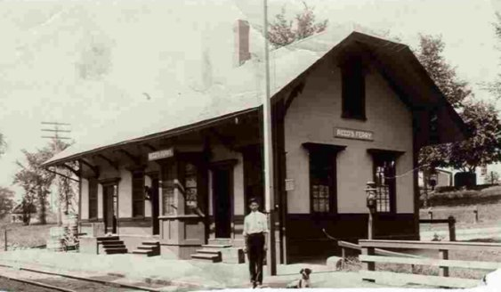

Agent Clarence Webster stands before his depot at Reed’s Ferry, New Hampshire
(courtesy of Janice Webster Brown)
[this photo may not be used without her express written permission]

