Celebrating Getting the Station Back on Track

Written by Ellen Chahey from the Barnstable Patriot July 2011

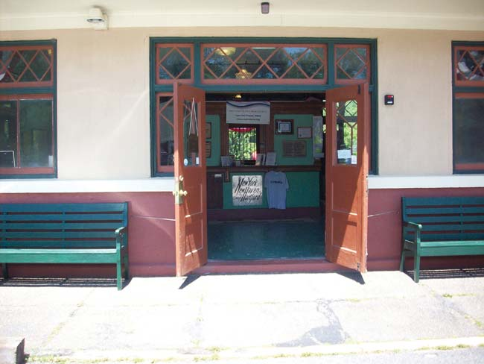
ELLEN C. CHAHEY PHOTOS
WELCOME! – On Saturday, July 9, the doors of the West Barnstable train station on Route 149 will open for a celebration of the station’s 100th anniversary and of the 25th birthday of the Cape Cod chapter of the National Railway Historical Society. All are welcome.
Centennial event to showcase improvements
West Barnstable got a brand new train station on July 8, 1911, but the building fell into disuse and eventually disrepair. On July 9, 2011, a 100th anniversary party will celebrate the station’s new lease on life as a stop on the Cape Cod Central Railroad, a museum and lending library, and the meeting place of the Cape Cod chapter of the National Railway Historical Society.
Chapter president Linda Z. Pegnato sat at a table in the CCCR’’s Race Point passenger car as the train rolled through the woods and bogs of the Upper Cape. She explained that the July 9 event, which will feature a ribbon-cutting ceremony at 10 a.m., also celebrates the 25th anniversary of the chapter.
She said that Gregory Molloy, the national president of the NRHS, plans to come from Ohio to attend the event. Other speakers will be John Kennedy, president of Cape Rail, Inc.; state Rep. Randy Hunt, who will present a citation to the chapter for its work; Town Councilor Hank Farnham; and Town Manager John Klimm.
The party will also feature cake, music, and rides on “Live Steamers,” a small train. A Cape rail video will be for sale as a fundraiser for future restoration projects at the station; Pegnato said that the wish list includes a heating system and new flooring. Admission to the party is free, but donations are welcome.
The building is owned by the town and leased to the NRHS chapter, which began restoring the boarded-up station in 2001. It has already appeared in two movies: The Golden Boys (alternatively known as Chatham) and The Lightkeepers.
The chapter plans to open the station every Saturday through October, from 9 a.m. until 2 p.m. Visitors can expect to find railroadiana of all kinds: equipment, posters, an old conductor’s uniform, props from the movies, even an antique telegraph that has been programmed to tap out a message. There is also a lending library of books and videos about trains.
Beginning at the celebration and continuing into December, raffle tickets will be sold for a handmade railroad-themed quilt.
The 1911 building replaced an 1854 wooden structure that had become too small for the needs of what was then a very busy station. According to NRHS materials, it served as an Amtrak station in the 1980s and 1990s.
“Our neighbors in West Barnstable are great,” said Pegnato, who was occasionally joined at the table on the train by her husband Fred, a conductor for Cape Cod Central. She praised Al Schofield of the Old Village Store, Ruth Jenkins of Cape Cod Feed and Grain, and Doug Pacheco, all of whose businesses border the station, and the various West Barnstable associations and the library and the fire department for their help and support. The program for Saturday lists dozens of acknowledgements, including one for the Barnstable County Sheriff’s Department, some of whose inmates were detailed to provide labor for the renovations.
Pegnato said that she would welcome more village members in her chapter, though. “Out of 70 members, only about six are from West Barnstable,” she estimated, and added that “even if you’re not a railroad person, you can help the community by joining” because the chapter gets involved in events such as the Spaghetti Supper, the Fourth of July parade, and the village festival, and also plans to rent the building for social and civic uses.
Soon the ride was over. Just before the train stopped in West Barnstable, Fred announced that there had been more out-of-state riders than Cape Codders. “We have riders today from New York, Rhode Island, Connecticut, Georgia, New Jersey, Belgium, and Germany,” he said over the PA system.
Back at the station, Pegnato displayed her checklist of preparations for the ribbon-cutting. It was labeled “100 Things To Do.”
“This is like planning a wedding, only ten times more,” she said, before posing with stationmaster Bruce Simmons next to “Jimmy,” a mannequin dressed in an authentic conductor’s uniform. Simmons has been in on the renovation project from day one. “I pried the first plywood off the door,” he said of his role in opening up the abandoned building.
The July event celebrates not just the building but the volunteer spirit, according to Pegnato, a retired legal secretary. “My motto is, ‘Those who can, do. Those who can do more, volunteer.’”
Even volunteers need some rest. Are she and Fred (who fell in love with trains when he was 4) going to take a vacation? Yes. Are they going on a train trip?
“No way,” she said with a light laugh. “We’re going to Key West.”
The website of the Cape Cod chapter of the National Railway Historical society is www.capecodnrhs.org. The phone number at the West Barnstable Railway Station and Museum is 508-362-WBTS (9287).
