Emmanuel Baptist Church fire in West Springfield blamed on faulty water heater
By George Graham, The Republican
on February 14, 2013 at 9:38 PM, updated February 14, 2013 at 9:48 PM

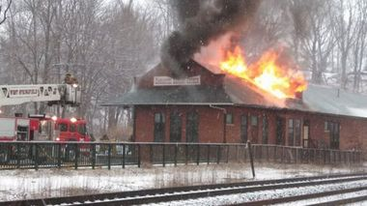2-14-13 - West Springfield - A faulty hot water heater was the cause of a blaze that heavily damaged Emmanuel Baptist Church on Front Street last Friday morning. Don Treeger / The Republican
WEST SPRINGFIELD - A faulty water heater was the cause of a fire that heavily damaged Emmanuel Baptist Church on Front Street Friday morning, Fire Chief William Flaherty said.
The blaze was reported shortly before 11 a.m. as winter storm Nemo bore down on Western Massachusetts. The water heater was located on the second floor and the fire spread into the attic and roof where damage was especially heavy, Flaherty said.
There was nobody at the brick structure at the time of the fire and no injuries were reported.

