Springfield's Union Station gets $6 million U.S. Department of Transportation grant

Published: Wednesday, October 12, 2011, 9:26 PM Updated: Thursday, October 13, 2011, 8:55 AM
By Suzanne McLaughlin, The Republican
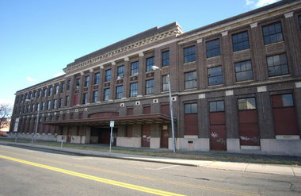
File photo | The RepublicanFile photo of the exterior of Union Station.

SPRINGFIELD - The U.S. Department of Transportation Wednesday announced the award of a $6 million grant for the Union Station Intermodal Transportation Center.
William Tranghese, spokesman for U.S. Rep. Richard E. Neal, D-Springfield, said the grant has been confirmed and is for construction of the station that will be used for Pioneer Valley Transit Authority local and regional bus service, Peter Pan and other intercity bus service, Amtrak passenger rail service and other future commuter and high speed rail service.
“Today’s announcement is another indication that the Union Station redevelopment project is moving forward in the right direction,” Neal said. “I have always believed that the successful rehabilitation of that historic landmark has the potential to transform the north blocks of downtown Springfield. This funding by the U.S. Department of Transportation is another significant investment in an intermodal transportation project that will serve the entire Western Massachusetts region.”
Construction of the long-stalled Union Station project is expected to begin in the summer of 2012.
The project is an estimated $70 million project. Tranghese said his understanding is that the $6 million announced Wednesday is part of the $70 million. There are $50 million in state and federal earmarks for it in place, although some have expired.
Plans call for renovations to the 200,000-square foot main terminal building and a refurbished passenger train platform. The existing freight building will be demolished and replaced with a 23-bay bus terminal topped by a 400-space parking garage.

