Train Depot Demolished
From: Preservation Online Story by Margaret Foster / Sept. 27, 2004
A train depot built in 1851 in Malden, Mass., was torn down earlier this month after years of neglect. The town ordered the dilapidated building's demolition.
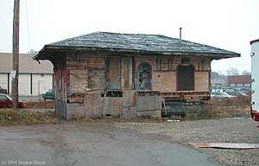
The Maplewood Depot, Malden, Mass. (Stephen J. Hussar)
Part of the Boston & Maine railroad line, the Maplewood Depot was one of the town's six stations, operated from the 1850s until the 1940s.
Two years ago, a group of residents called Friends of Maplewood Depot raised $15,000 and moved the wood building out of harm's way.
"We were going to make it a little community center," says Dave Waller, a Malden resident who has restored a diner, a firehouse, and many neon signs. "We just wanted to save it. Anything was better than knocking it down."
The Maplewood Depot was moved to a temporary site near a model-train store but never refurbished. Charles Ro, the owner of the store, planned to restore the depot, but he never acted on his ideas. Meanwhile, a neighbor wanted the building removed from his property.
"We just had to walk away after a while because we realized we had gotten in the middle of a fight," Waller says.

